**F**

**OAWA LMS TECHNICAL DESIGN DOCUMENT**

**<<Project Name>>**

*Document Version :* ***1.0***

*Last Validated:* ***<<DATE>>***

*Author****: <<NAME>>***

Table of Contents

Document Administration 3

Document History 3

1. INTRODUCTION 4

1.1. PURPOSE OF THIS DOCUMENT 4

1.2. CURRENT SYSTEM 4

1.2.1. LIMITATION OF THE SYSTEM 4

1.3. PROPOSED SYSTEM 4

1.4. AUTOMATION / PRODUCT OBJECTIVE 4

1.5. PROJECT SCOPE 4

1.6. PRODUCT FEATURES 4

2. PROCESS FLOW 4

3. DATABASE DESIGN 4

3.1. API DESIGN

4. APPLICATION ARCHITECTURE 5

5. MODULES DESCRIPTION 5

5.1. MODULE 1 5

5.2. MODULE 2 5

6. OPERATING ENVIRONMENT 6

7. ASSUMPTIONS AND DEPENDENCIES 8

8. APPENDIX 8

Document Administration

This section tracks the history of authorship and changes made to the design.

### Document History

The following changes have been made to the document.

|  |  |  |  |
| --- | --- | --- | --- |
| Date | Version | By | **Changes** |
|  |  |  | Initial Draft |
|  |  |  |  |
|  |  |  |  |
|  |  |  |  |

1. INTRODUCTION
   1. PURPOSE OF THIS DOCUMENT

This document will provide a general description of the software system, including overview of requirements, constraints, design and user view of the application.

* 1. CURRENT SYSTEM

Give a brief note on the current system.

* + 1. LIMITATION OF THE SYSTEM

Please provide the limitation of the current system in short and bulleted manner.

* 1. PROPOSED SYSTEM

Give a brief description about the application and its proposed working and benefits.

* 1. AUTOMATION / PRODUCT OBJECTIVE

Provide the benefits of the automation in short and bulleted manner.

* 1. PROJECT SCOPE

Define the scope of the project here and what we are supposed to get from the application.

* 1. PRODUCT FEATURES

Please provide the features of the application in a bulleted manner.

1. PROCESS FLOW

Please provide the workflow of the application.

1. DATABASE DESIGN

Please provide the db diagram here and a short description of the main tables.

3.1. API DESIGN

3.1.1. Authenticate

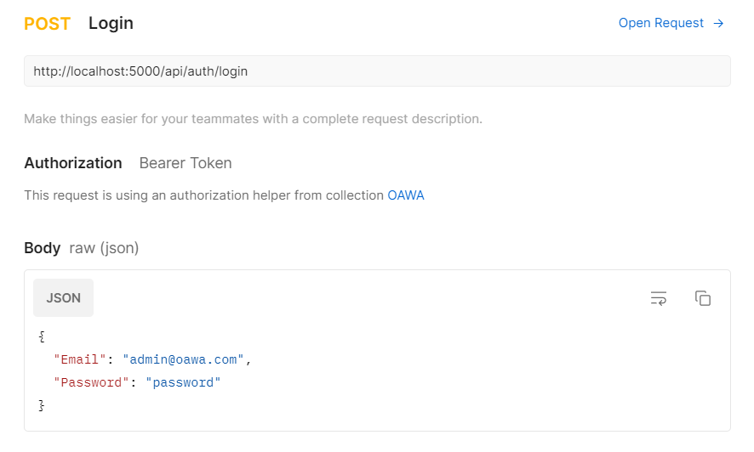

3.1.2. Logout

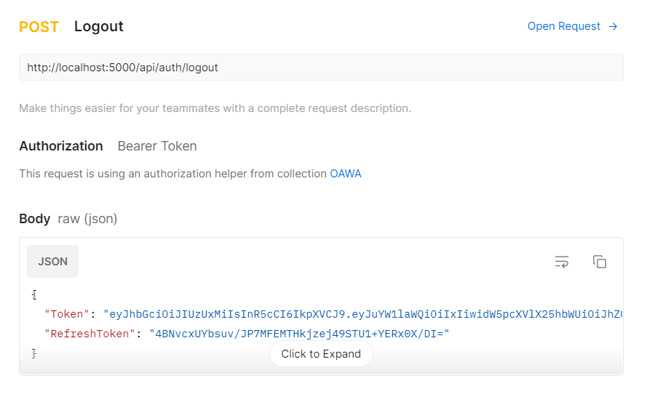

3.1.3. Refresh Token

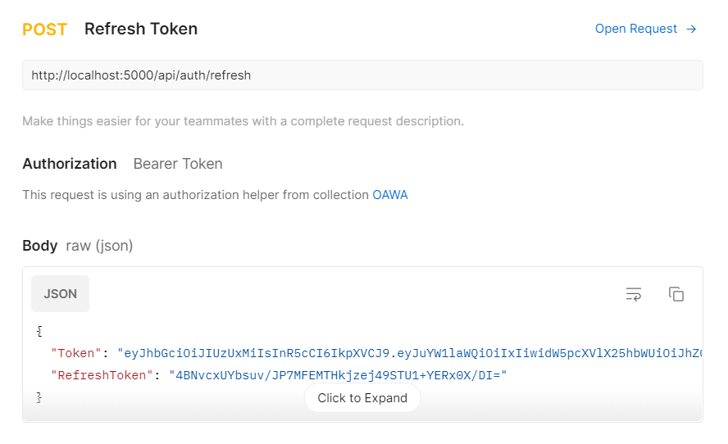

* 1. DATABASE MIGRATIONS
     1. CREATE MIGRATION FILE

Dotnet CLI> Dotnet ef migrations add “InitialDesign”

* + 1. UPDATE DATABASE

Dotnet CLI> Dotnet ef database update

* 1. DATABASE TABLES
     1. ASPNETUSERS
     2. ASPNETROLES
     3. ASPNETUSERROLES
     4. USERSESSIONS

1. APPLICATION ARCHITECTURE

Please provide the application architecture here.

1. MODULES DESCRIPTION

Here please provide the list of modules in the application and also provide the short description for each. List down the main pages in the module.

* 1. MODULE 1

Description.

* 1. MODULE 2

Description.

1. OPERATING ENVIRONMENT

***App and DB server Spec required for the application as sample general spec is given below***

* The ***Application Server*** would have the following configuration:-
* Intel Quad Core machine with 3.0 GHz Processor(4 Nos.).
* 4 GB RAM.
* C drive having 40 GB HDD and OS - Raid 10.
* D drive having 80 GB HDD and Raid 10 / 5
* The OS would be Windows 2008 or above.
* IIS Server.
* Dot Net framework 3.5/4.
* The ***Database Server*** would have the following configuration:-
* Intel Quad Core with 3.0 GHz Processor (4 Nos.).
* 6 GB RAM.
* C drive having 40 GB HDD and OS - Raid 10.
* D drive having 50 GB HDD and Raid 10 / 5.
* E drive having 50 GB HDD and Raid 10.
* F drive having 50 GB HDD and Raid 0.
* The OS would be Windows 2008 or above.
* SQL Server 2008 or above .
* The ***BCP App*** ***Server*** would have the following configuration:-
* Intel Quad Core with 3.0 GHz Processor (4 Nos.).
* 4 GB RAM.
* C drive having 30 GB HDD and OS - Raid 10.
* The OS would be Windows 2003.
* SQL Server 2008.
* I IIS Server.
* Dot Net framework 3.5.
* The ***User System*** should have the following configuration:-
* Intel P4 with 2.66 GHz Processor.
* 1 GB RAM.
* C drive having at least ***2 GB free space.***
* ***Internet Explorer 6.0 (IE 6.0)*** and above.
* System resolution of 1024 x 768.

1. ASSUMPTIONS AND DEPENDENCIES

Please provide here any assumptions taken during the design of the system and is there any dependency there, dependency can be another application or feed files provided by the client etc.

1. APPENDIX

N/A